

User Manual

**Hi, welcome to FETCH! A web application that allows you to read, review, and rate products. FETCH! Is your number one location for product reviews.**

This user manual will serve as a guide to help you operate our website. Once finished reading this guide, the user should know how to do the following:

1. **Create an account**
2. **Navigate the user profile**
3. **Look at reviews on products with/without creating an account**
4. **Post a review**
5. **Rate reviews on products**
6. **Search a product for reviews.**
7. **Create an Account:**

**In order to post reviews on FETCH! You’ll have to create an account on our website. Note: You don’t have to create an account to view content on our website.**

**Follow these Instructions to create an Account:**

1. **Navigate the user profile**

**Once you’ve created an account on FETCH! You’re ready to navigate through the user profile page.**

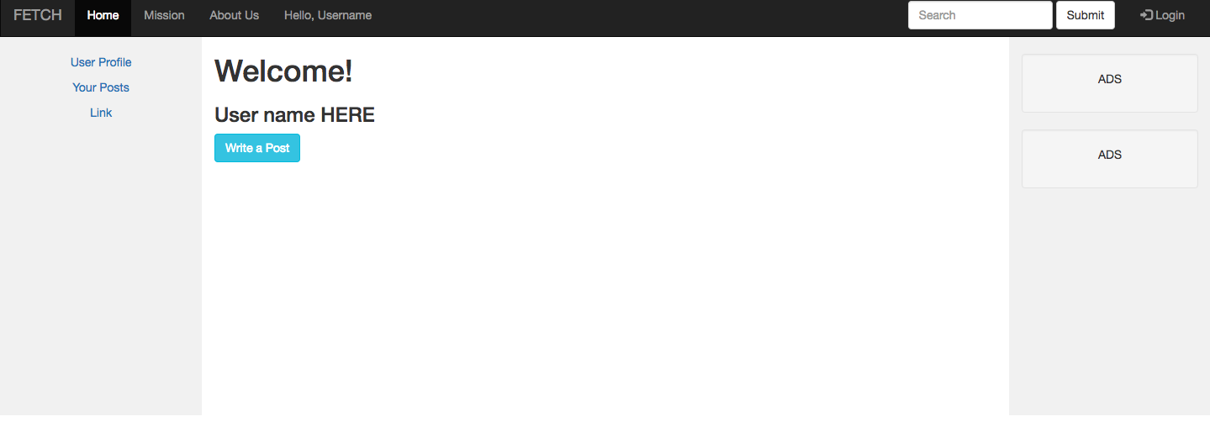

If you click “User Profile” you’ll be brought back to this page.

If you click on “Your Post” you’ll be prompted to a page to view all of the post, you as a user has posted on FETCH!

1. **Look at reviews on products on FETCH!**
2. **Post a review on FETCH!**

**In order to post reviews on FETCH! You’ll have to create an account on our website. Note: You don’t have to create an account to view content on our website.**

**Follow these instructions to post a review:**

* **On the Main page, click on the tab in the top left folder, “hello username”.**

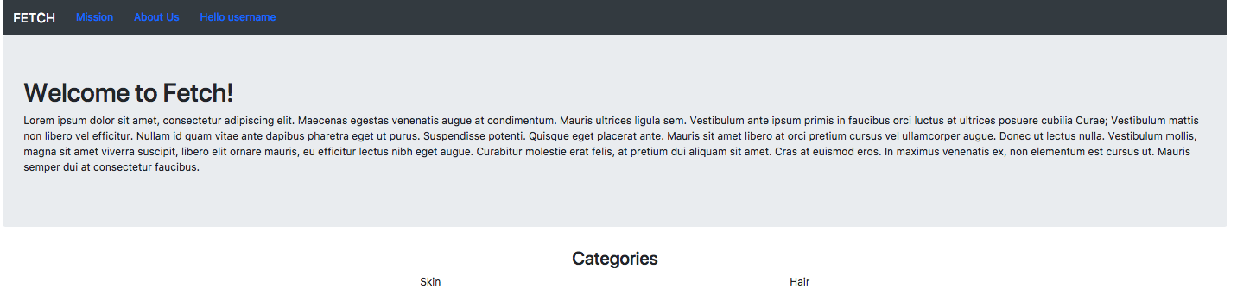

* **Once you click on “hello username” it should prompt you to log in. If you have you have not logged in already, please do so. Note: You need to create an account in order to post a review.**
* **After you log-in you should be prompted to the profile page.**



**Click on the blue button “Write a Post” in order to write a review on a product!**

1. **Rate reviews on products**
2. **Search a product to look at reviews**

**To search products on FETCH! Just visit any of the search bars on our website and search a product of your choice. Note: FETCH! Is still in development and we only have a limited amount of products in out database, but we do plan on increasing the items in the future.**